SYNSCAN.PCAPNG

OPEN PORTS

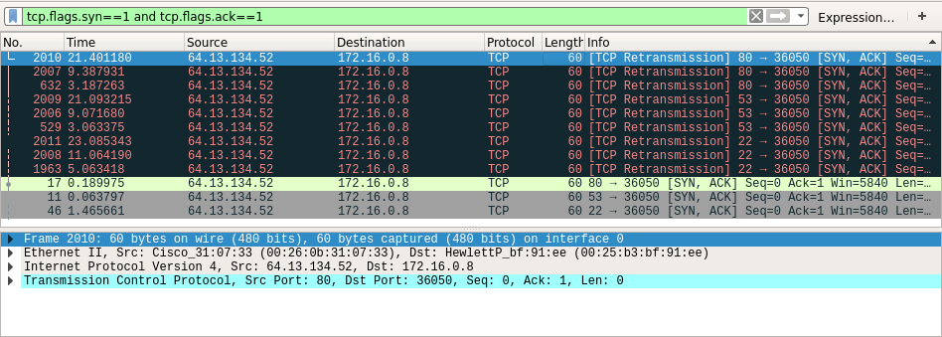
If a port is open, then after the [SYN] packet is received, the server sends a [SYN, ACK] packet back to the client. By setting the filter as tcp.flags.syn==1 and tcp.flags.ack==0, we are filtering out the [SYN, ACK] packets from the packet list. Hence, the open ports are

80
53
22

CLOSED PORTS

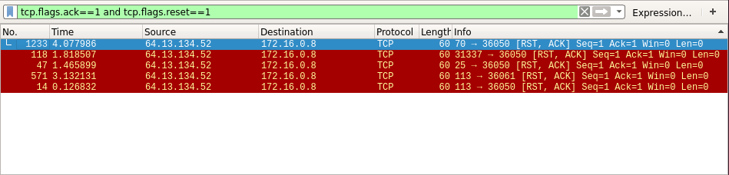
If a port is closed, then it responds with a [RST, ACK] packet after receiving the [SYN] packet. We have set the filter as tcp.flags.ack==1 and tcp.flags.rst==1, which shows only [RST, ACK] packets. The closed ports are

79
31337
25
113

FILTERED PORTS

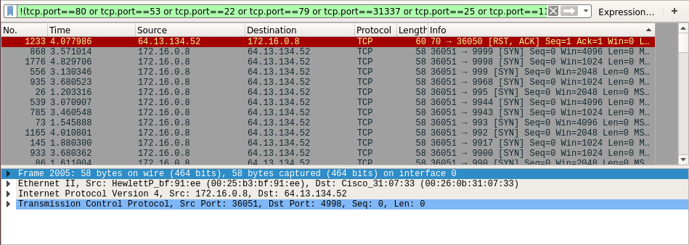
The ports which are neither open or closed are filtered ports. Hence, the condition is set as
!(tcp.port==80 or tcp.port==53 or tcp.port==22 or tcp.port==79 or tcp.port==31337 or tcp.port==25 or tcp.port==113) which displays all other ports.

